**SYNOPSIS**

**Report on**

**E.C.H.O:-VOICE ENABLED VIRTUAL ASSISTANT**

**By**

Shivani Sahu - 2300290140173

Vinayak Saxena - 2300290140202

Srishti Bhatt - 2300290140178

**Session: 2023-2024 (III Semester)**

Under the supervision of

**Ms. ANNU YADAV (Assistant Professor)**

### KIET Group of Institutions, Delhi-NCR, Ghaziabad



### Department Of Computer Applications

**KIET GROUP OF INSTITUTIONS, DELHI-NCR, GHAZIABAD-201206**

( 2024-2025)

**ABSTRACT**

This project is focused on developing a voice-enabled virtual assistant using python, aimed at enhancing human-computer interaction through voice commands. The virtual assistant is designed to recognise, process, and respond to voice inputs, enabling users to control various tasks and applications hands-free. Key technologies used include speech recognition, natural language processing, and text-to-speech synthesis. The assistant utilizes Python libraries such as Speech Recognition, pyttsx3 to interpret spoken commands and convert them into actionable tasks.

The system is designed to handle a variety of functions, including opening applications, searching the web, fetching real-time information, sending emails and playing music. The modular architectures of the project ensures scalability, allowing for the addition of new features and functionalities in the future.

The goal of this virtual assistant is to create a more natural and efficient way for users to interact with their computers, improving accessibility and productivity by minimizing the need for manual input. This project demonstrates the practical application of voice-driven technology in everyday computing tasks, offering a glimpse into the potential of voice assistants in personal and professional environments.

**TABLE OF CONTENTS**

|  |  |  |
| --- | --- | --- |
| **S.No** | **Content** | **Page No.** |
| 1. | Introduction | 4 |
| 2. | Literature Review | 5 |
| 3. | Project/ Research Objective | 6 |
| 4. | Project Flow/ Research Methodology | 7-8 |
| 5. | Project/ Research Outcome | 9 |
| 6. | Proposed Time Duration | 10 |
| 7. | References/ Bibliography | 11 |

**INTRODUCTION**

In the era of rapid technology advancements, virtual assistants have become an integral part of our daily lives, revolutionizing how we interact with machines. From smartphones and smart speakers to cars and home automation systems, voice-activated virtual assistants like Siri, Alexa, and Google Assistant have demonstrated their ability to provide users with hands-free convenience. The increasing demand for such systems presents aa unique opportunity for developers to explore and create their own customized virtual assistants.

This project focuses o developing a voice-enabled virtual assistant using Python, with its simplicity and rich libraries, has become a popular choice for implementing AI-Based systems. The virtual assistant in this project is designed to understand and respond to human voice commands, performing a variety of tasks such as fetching information from the web, setting reminder, playing music, sending emails and controlling system application among others. By leveraging speech recognition and natural language processing, the assistant can interpret user inputs and provide appropriate responses or execute commands.

Key Python libraries like SpeechRecognition, Pyttsx3 for text to speech conversion, these libraries allow the virtual assistant to communicate naturally, provide relevant information, and interact with online and offline resources seamlessly. Additionally, advancements making it more intuitive and user-friendly.

This project demonstrates not only the versatility of Python in building AI-driven applications but also provide insight into the growing trend of voice-driven technology. The potential for customizing or the scalability of it is high as new features can easily be introduced with the advancement in technology.

**LITERATURE REVIEW**

|  |  |  |  |
| --- | --- | --- | --- |
| **AUTHOR** | **YEAR** | **TITLE** | **CONCLUSION** |
| Sakshi R Jain,  Prof. Feon Jason | 2023 | Personal Desktop Voice Assistant | In this paper, the benefits and shortcomings of Personal desktop assistant are discussed. |
| Yuqi Huang | 2023 | Research on the development of voice assistants in the era of AI. | This paper discusses the booming and broad development status of artificial intelligence voice assistant and how the use of voice assistant differ country to country. |
| Rodrigo Pereira,  Claudino Lima,  Et el. | 2023 | Virtual Assistants in industry 4.0 | This paper explores the use of Vas in the industry 4.0 discussing the technical assistance design principle and identifying the characteristics of VA. |
| Yanchu Guan,  Dong Wang, Et el. | 2023 | Intelligent Virtual Assistant with LLM process automation. | This paper proposes a novel LLM based Virtual assistant that can automatically perform multi-step operations within mobile app based on high level requests. |

**PROJECT OBJECTIVES**

This project aims to reduce human effort by enabling task completion through their voice, Users can easily be able to complete some of their tasks just by giving voice commands.

Following are the Objectives that are needed to be accomplished.

* **SPEECH RECOGNITION:** Implement accurate speech-to-text functionality using libraries like SpeechRecognition to allow the assistant to understand spoken commands.
* **NATURAL LANGUAGE PROCESSING:** Utilize libraries like NLTK or spacy to enable the assistant to process and understand user input effectively.
* **VOICE RESPONSE:** Incorporate text-to-speech functionality using libraries like pyttsx3 or googles text-to-speech API to allow the assistant to respond in a natural, human-like voice.
* **TASK AUTOMATION:** Enable the assistant to perform tasks such as sending emails, or opening applications through python’s OS and smptlib libraries.
* **MODULAR AND SCALABLE DESIGN:** Ensure the project is modular, allowing future enhancements such as adding new commands or expanding functionality without significant rework.

**PROJECT FLOW/ METHADOLOGY**

For the Virtual Assistant a structured methodology to ensure efficient development and implementation is necessary.

1. **REQUIREMENT GATHERING AND ANALYSIS:**

* Identify the core features: Define what functionalities theassistant will have, such as speech recognition, NLP, tasks automation etc.
* Target audience and Use case: Determine whether the assistant will be for general use or specialized tasks.
* Technology Stack-selection: Choosing the correct libraries like SpeechRecognition, NLTK, pyttsx3 etc.

1. **DESIGN PHASE:**

* System architecture design: Break down the project into modules.
* User Interaction design: Sketch the conversational flow-how users will interact with the assistant and how it will respond.
* Database/Storage design: Plan any necessary data storage for saving preferences, learning from user inputs, or logging interactions.

1. **DEVELOPMENT PHASE:**

* Speech-to Text Module: Implement speech recognition using SpeechRecognition or other libraries.
* Text Processing Module: Build the NLP engine using libraries like nltk, or queries, file management, or setting reminders.
* Task Execution Module: Develop the logic to handle various commands such as web queries, file management, or setting reminders.

1. **TESTING PHASE:**

* Unit Testing: Test individual modules to ensure they work as expected.
* Integration and User testing: test how different components work together as a complete system, and having users interact with the assistant and provide feedback on usability, accuracy, and functionality.

1. **OPTIMIZATION AND REFINEMENT:**

* Performance Tuning: Optimize the speed of speech recognition, NLP, and response generation.
* Error Handling: Implement robust error handling to ensure functionality even when unexpected input is provided.
* Machine Learning Enhancements: Add adaptive features that allow the assistant to improve responses based in user interactions or preferences.

**PROJECT OUTCOME**

These following outcomes can help us create a comprehensive and functional virtual assistant that can significantly enhance user productivity and experience.

1. **TASK AUTOMATION:** This project aims to create a virtual assistant that could automate routine tasks such as setting reminders, sending emails, or managing your calendar.
2. **VOICE INTERACTION:** Implementing voice recognition and response capabilities, allowing users to interact with the assistant through natural language, this could be achieved by using python libraries like SpeechRecognition, pyttsx3, Scikit-learn etc.
3. **INFORMATION RETRIEVAL:** The assistant could fetch information from the web, such as weather, updates, news, or answers to general knowledge questions.
4. **NATURAL LANGUAGE PROCESSING:** Implementing NLP techniques to understand and process user commands more effectively, these include parsing sentences, recognizing entities, and generating coherent responses.
5. **SCALABILITY:** Deigning the system to be modular and scalable, allowing for easy addition of new features and functionalities. New Features like; language translation or sentiment analysis without overhauling the entire system.

**PROPOSED TIME DURATION**

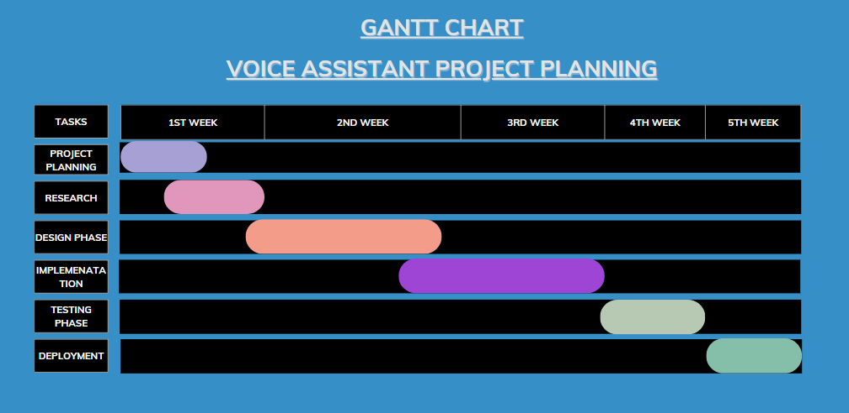

**REFERENCES/ Bibliography**

1. Jain, S. R., & Jason, F. (2023). Personal Desktop Voice Assistant. In this paper, the benefits and shortcomings of personal desktop assistants are discussed. Retrieved from [URL](https://ijarcce.com/wp-content/uploads/2023/03/IJARCCE.2023.12324A.pdf)
2. Huang, Y. (2023). Research on the Development of Voice Assistants in the Era of AI. This paper discusses the booming and broad development of artificial intelligence voice assistants and how their use differs across countries. Retrieved from [URL](https://www.researchgate.net/publication/367077879_Research_on_the_Development_of_Voice_Assistants_in_the_Era_of_Artificial_Intelligence)
3. Pereira, R., Lima, C., & Et al. (2023). Virtual Assistants in Industry 4.0. This paper explores the use of virtual assistants in Industry 4.0, discussing the technical assistance design principles and identifying the characteristics of virtual assistants. Retrieved from [URL](https://www.researchgate.net/publication/374396850_Virtual_Assistants_in_Industry_40_A_Systematic_Literature_Review)
4. Guan, Y., Wang, D., & Et al. (2023). Intelligent Virtual Assistant with LLM Process Automation. This paper proposes a novel LLM-based virtual assistant that can automatically perform multi-step operations within mobile apps based on high-level requests. Retrieved from [URL](https://dl.acm.org/doi/pdf/10.1145/3637528.3671646)